Activity to live with pupils, to share with european teachers

Title | Science and Tehcnology in kindergarten
Learners’ age | 2,5 to 6 years
Approximate duration | Half a day or a day

Subject (please check X)
mother language | art and culture | X mathematics | X sciences | X technology
philosophy/religions | history | geography | music | physical education
X ICT | other :

Learning objectives | - learn about the scientific and technical approach (observation, question, planification, research, manipulation, verification, synthesis, trial and error approach, problem solving)  - spatial vocabulary, topology, plan, 2D/3D, enumeration, rotation, symmetry, abstraction …

21st century skills that activity will improve
Life competence | Digital competence
X Personal (self-regulation, flexibility, wellbeing) | Information and media literacy (understand the content in digital environment, create and adapt a search, access to digital information and navigate between them)
Social (empathy, communication, collaboration) | Communication and collaborative learning (interact through a variety of digital technologies, be aware of behavioural norm, share digital content with others, protect one’s own reputation
Learning to learn (growth mindset, critical thinking, managing learning) | X Digital content use and creation (use digital technologies to visualize and understand concepts; create, modify or edit digital content in different formats; plan and develop a sequence of understandable instructions (code))
X Creativity (curiosity, open-Mindedness, imagination, problem solving) | Responsible use (protect devices and understand risks and threat, understand safety and security measures)

What would you like to share?
X classroom activity | online activity |  | outdoor activity
X in-school activity X teacher guidance  autonomous |  | at home activity parental guidance  autonomous
video |  | information document
digital game for children |  | powerpoint presentation

Resources required
Human | A teacher (at least )
Material | - A blue-bot + grid, arrows (!!! size depending of the mouse)+ a cheese, a “cat” or obstacles  - A turing tumble + models + cards with necessary material  - A box of gears with cranks + pictures to classify + models+ everyday objects  - Material to make a lever + teddies + legos (+ a book with the story) + cards to complete + everyday objects  - A box of lego machines+ models + videos+ card with vocabulary
Digital | a computer with internet connection (for bookcreator) and, if possible, an interactive with board

Organization
Introduction | Today we are going to live a special day. We will discover how different machines and technical tools work. You will go through 4 workshops (+ explanations). Throughout the day we will take photos to create a book with everything we have learned. At the end of the day, you will receive a science and technology hero diploma for all the challenges you complete.
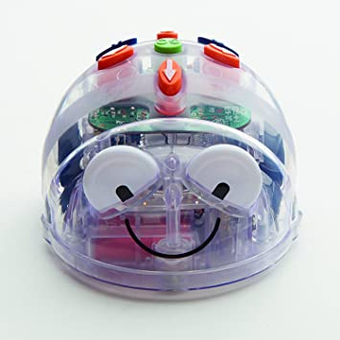  Blue-bot | - Free handling: children explore material.  - Bodily experience: children move on the way  - Guidance: children guide the mouse gradually  - Programming: children program the mouse from the start  - Progress: Same thing with models and with obstacles  - Structuring: children explain what they have learned.
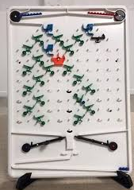  Turing Tumble | - Free handling: children explore material  - Planning: children prepare necessary parts  - Arrangement: children place the pieces in the right place  - Checking: children release marbles.  - Progress: Same thing with more complicated level  - Structuring: children explain what they have learned.
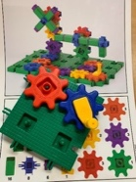  Gears | - Free handling: children explore material  - Gear or not gear? children make hypotheses and verify.  - Arrangement: children make a construction with a model  - Transfer: children discover objects that work like this  - Structuring: children explain what they have learn
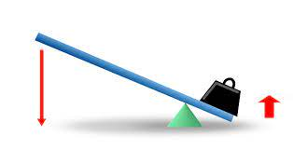  Lever | - Problem situation: tell a story to the children to introduce the problem (for ex., two characters playing seesaw)  - Handling and hypotheses  - Problem solving: children check their hypotheses.  - Transfer: children discover objects that work like this  - Structuring: children explain what they have learn
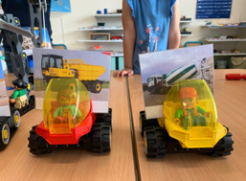  Lego machines | - Free handling: children explore material  - Context: Children discover real machines (videos)  - Arrangement: children make construction with model  - Structuring: children associate he right words with the machines  - * you can also speak about safety equipment
Conclusion | - Book creator: The children create the digital book together to summarize the learning. For each workshop, the children choose the photos and make the audio recordings to explain what they are doing. They can also add specific words. At the end, the book is shared with the parents.  - Diploma: children receive a diploma with their discoveries.
TIPS | - Properly prepare and test the equipment  - Have clear instructions  - Use specific terms  - Gradually decrease the guidance  - Do not have too many children (3 for Turing)  - Do not plan too long

